**Bookmark User Manual**

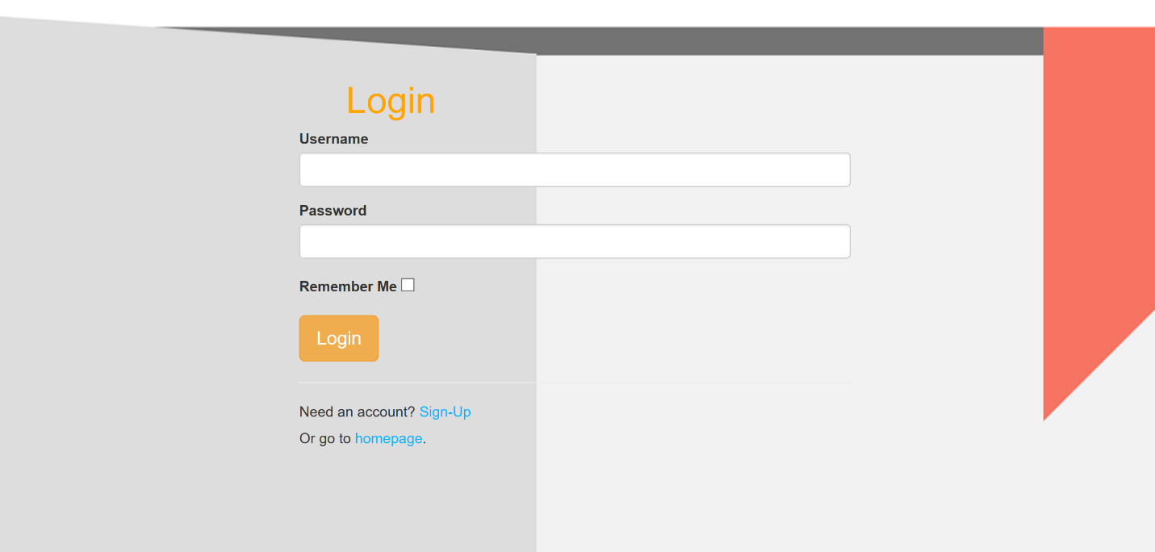Login Screen

Insert password

Insert username

* Make sure to register through the sign-up page before logging in

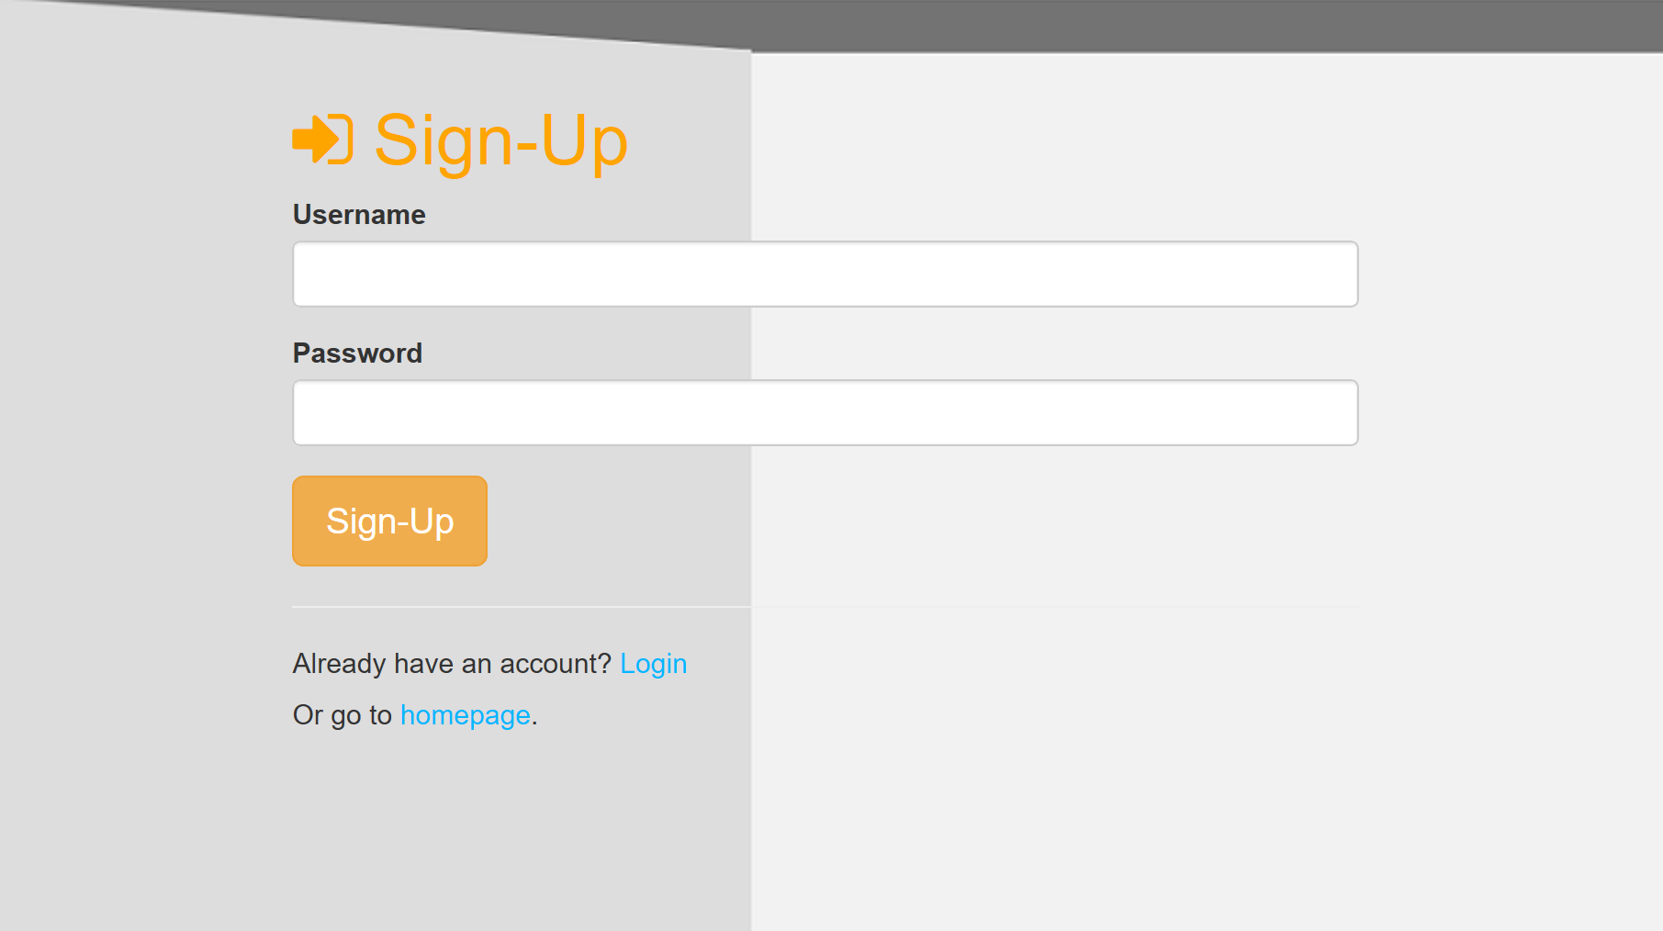Register

password

**Insert new:**

username

Add Book

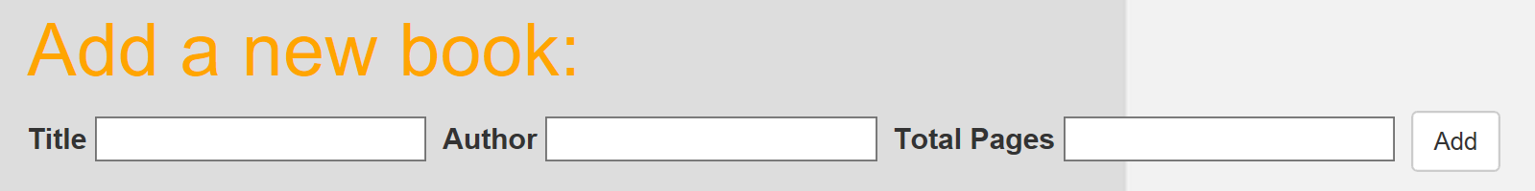

Insert book information

Click to confirm book entry

Add/Update Bookmark

1. 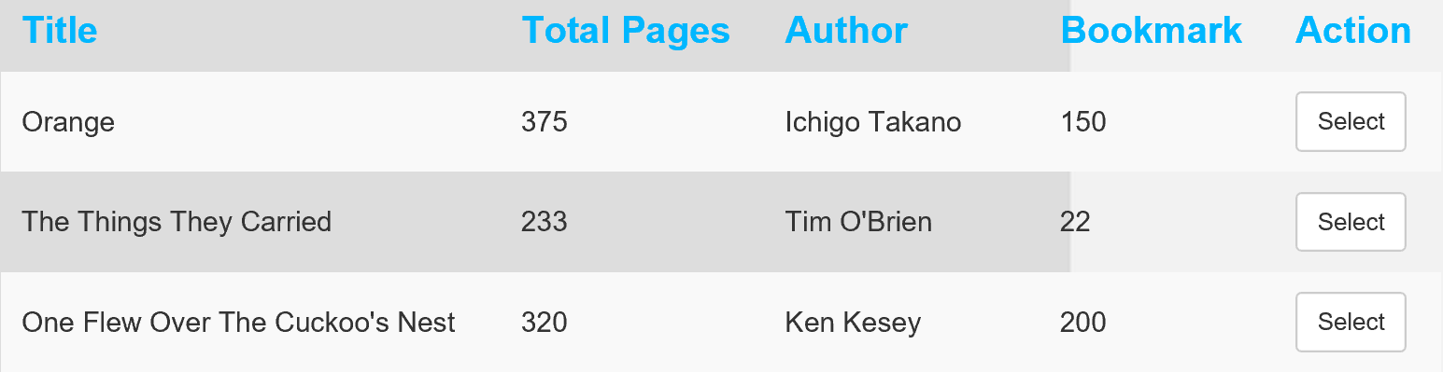Select a book entry

Click to select



Selected book

Insert number of pages read

Confirm bookmark